Ram Setu: Real truth behind the ‘floating stones’
By Pallavi Thakur
Posted on Feb 24, 2015 at 05:02 pm
1
Did Rama really exist?
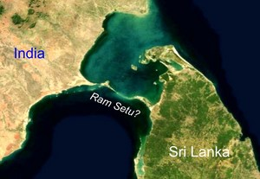
Is Rama Historical? While divinity is a matter of faith, Historicity is a matter of existence. In the last 100 years giant strides have been made in understanding History using modern scientific rules. So let us look at the Ram Setu with a fresh scientific prospective and try to differentiate between myth and reality…
2
The description of Ram Setu in Ramayana
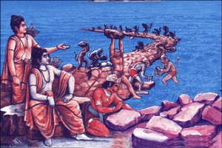
The building of Rama's bridge is described in the chapter titled ‘Yuddha Kanda’ of the Ramayana, but the description is rather vague. When Rama wants to use an arrow to dry up the ocean, the ocean god says: O, excellent man! This one, named Nala, a glorious person, is the son of Vishvakarma; who was given a boon by his father and is equal to Visvakarma. Let this greatly energetic monkey build a bridge across me. I can hold that bridge.
3
Description of the bridge
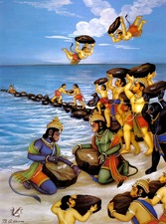
From here and there the monkeys brought Palmyra trees, pomegranate shrubs, coconut and Vibhitaka, Karira, Bakula and neem trees. The huge bodied monkeys with mighty strength uprooted elephant-sized rocks and mountains and transported them by mechanical contrivances. The water, raised up due to sudden throwing of mountains in the sea. The rocks befalling on all sides perturbed the ocean. Some others drew up strings a hundred Yojanas long (to keep the rocks in a straight line.)
4
Neel and Nala’s role
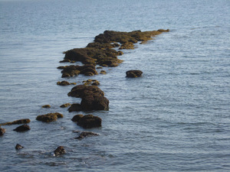
Nala on his part initiated a monumental bridge in the middle of the ocean. Some monkeys were holding poles for measuring the bridge and some others collected the material. Reeds and logs resembling clouds and mountains, brought by hundreds of monkeys, lead by the command of Rama, fastened some parts of the bridge. On the first day, fourteen Yojanas of bridge were constructed by the monkeys speedily. In the same manner, on the second day twenty Yojanas of bridge were constructed.
5
The description isn’t enough
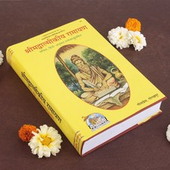
The passage isn't explicit about the role of the trees, but it provides some indication; it says that the logs "fastened some parts of the bridge". This is all just speculation. Tulsi Das' Ramcharitmanas provide more detail about Nila and Nala getting a curse that would make anything they throw into the water float, but such specificity isn't there in the original Ramayan's account of the building of the bridge.
6
Incredible facts about Rama Setu
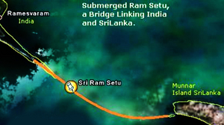
Rama Setu took 5 days to build by 10 Million Vanaras (Monkeys) under the supervision of Architects Neel and Nala. Age and Structure Rama Setu is 1.7 Million Years Old. It is believed that RAMA Setu is made of a chain of limestone shoals. It is 30 Km Long and 3 Km Wide. It Starts from Dhanushkodi tip of India’s Pamban Island and ends at Sri Lanka’s Mannar Island. Sea in these areas is very shallow.
7
Mystery of Floating Stones
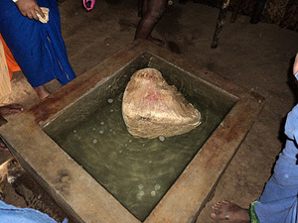
In Ramayan it is mentioned that the bridge was built by Stones and these stone starts Floating on water by touch of Nala & Neel. Some such stones were scattered at Rameswaram during the Tsunami ,these stones still float on water. Many Geologist says RAMA Setu is built by natural process but failed to Provide enough proofs. Apart from Ramayana there are several facts which say Rama Setu is Man-made Structure.
8
Facts that prove it is Man Made
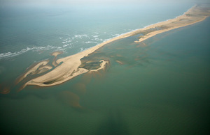
The places mentioned in Ramayan exactly matches to the current location of the bridge. Temple records say that Rama’s Bridge was completely above sea level until it broke in a cyclone in AD 1480. Ram Setu was walkable till 1480 AD. NASA Says what had been captured by satellite is naturally occurring chain of sandbanks.
9
Ram Setu is not God’s miracle
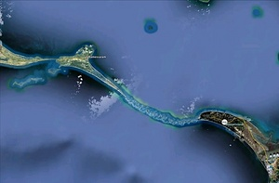
Battle between Science & Spirituality is running over a decade. Science relies on logics , facts & proofs whereas Spirituality is largely related to belief. According to Hindu belief Ram Setu was built by Lord Rama to cross the sea. Stones used to make the bridge floated on water because Rama was written on stones. But there is a complete scientific explanation why stones floated on water & why now Ram Setu is under water.
10
A scientific possibility
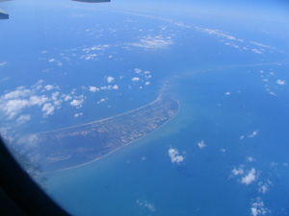
If air is trapped within a shell of silica it would look like a stone but would actually be very light and would thus float. Another example is Ice. When put into glass having liquid, ice floats on liquid & after some time it sinks. Another prime example is of “Pumice” stone.
11
About Pumice stone
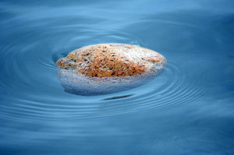
Pumice is one such stone that floats on water. Pumice is the name given to the hardened foam of lava when it comes out of a volcano. The inside of a volcano has very high pressure, and can be as hot as 1600 degree Celsius. When the lava comes out of the volcano, it meets the cool air (and sometimes sea water), which is around 25 degree Celsius.
12
Two things happen immediately
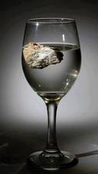
Air and water that were mixed in the lava bubble out, as the pressure falls. The huge difference in temperature gives the lava a ‘cold shock’, so it freezes almost immediately. So the bubbles get trapped in the freezing stone, giving it a very spongy appearance. In some kinds of pumice, the bubbles can make upto 90% of the volume.
13
Dense stones do not float on water
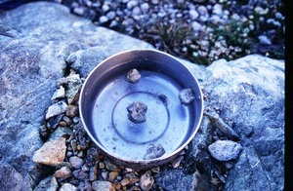
But because pumice is full of air bubbles, it is less dense than water. So in the beginning it will float. But in time, water will enter the bubbles driving out the air. Slowly, the pumice sinks. This also explains why the Ram Setu is under water today. Pumice doesn’t float forever. However, this theory is not 100 per cent correct. Read on to know how some scientists dismiss the Pumice stone theory….
14
Strange floating stones of Rameshwaram
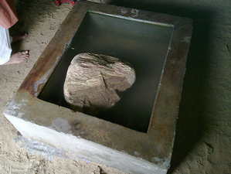
Some floating stones are found on the coastal regions of Rameshwaram. These stones are similar to any other stone and possess the same features, physical and chemical composition like the stone you may find in your locality. Seeing these stones from a far distance, you may feel that this stone is made of corals but on physical examination, it is found that this is not a coral stone...and neither is it a pumice stone!
15
Debunking the Pumice stone theory
There is no volcano near Rameshwaram nor is there any evidence which claims the existence of volcano in the areas surrounding Rameshwaram over the last few millions of years. Also, floating stones of Rameshwarm are not light weighted like pumice rocks and doesn’t have the chemical composition similar to pumice rocks.
16
There is no exception
It might be possible that this is some special kind of heavy pumice rocks found only at Rameshwaram but if this would have been the case, then it would have been confirmed by Indian archeologists. According to visitors, some of the stones do look like pumice but are extremely heavy to be called as pumice. Also, color of the pumice rocks is white or creamish in color but there are many black floating stones in Rameshwaram.
17
NASA images of Ram Setu
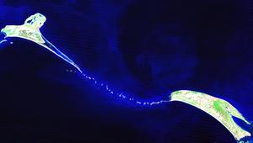
This bridge made of floating stones can still be seen between India and Sri Lanka from Rameshwaram, the place where Lord ram prayed to lord Shiva and started the construction of the bridge. Since this story is very old and unproven, many historians, scientists and archaeologists deny accepting this bridge to be built by lord Rama but at the same time they are unable to explain the concept of floating stones found in Rameshwaram.
18
It’s not Ram Setu but corals?
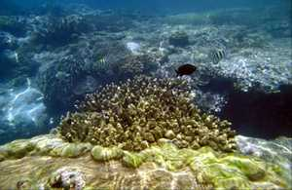
Scientist has been claiming far and wide that the stones of ram setu are actually coral formation. Nasa scientists even release the photo where they claims the Ram setu underwater bridge to be coral formation. Take a look at the image release by their space shuttle.
19
No, there is definitely a bridge out there!
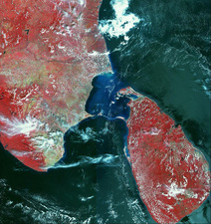
There is nothing like floating coral because coral is calcium carbonate, and its chemical composition is too dense to float on water. Geologist claims that after years of formation of layers on ocean bed, coral stones are formed within the layer, but when they were asked why these stones were formed only in Rameshwaram and nowhere else there were no answers. Also, coral stones don’t occur naturally in the sea, they occur only on hard surface.
20
Unknown science behind floating stones
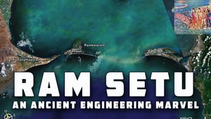
Until the scientists come up with a convincible theory maybe we can consider Rama Setu as an engineering masterpiece. The technology once existed to make stones float on water and the architect like Nala and Neela were too advanced in building a bridge from India to Sri Lanka within 5 days with the help of dedicated work force of million Vanaras.

